Creative Coding

Assignment #2

TU850/1: BSc (Hons.) Data Science
and Artificial Intelligence

Due Date: 1st May 2025

Please fill out the attached template where you will describe the work you undertook in doing Assignment #1. Additionally change all of the text that is in RED into BLACK. Here’s what you have to do:
- Section 1.1: Leave it exactly as it is.
- Section 1.2: Add in whichever generative AI tool you used, and if you didn’t use one, just delete that bullet point.
- Section 1.3: Leave it exactly as it is.

- Section 2.X: For all of the subsections in Section 2, post the image you generated from Assignment 1. Get rid of all the white boundary around the image you created, as demonstrated below:
 | 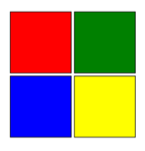 |  | 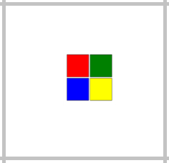
 |  |  | 

Each section asks how long it took you to draw the figures, don’t worry too much, just a rough guess is fine.
If you used Generative AI, write down 1 or 2 prompts you used for that diagram (it doesn’t have to be the exact prompt, just a reasonable representation of the prompt is fine). Then add a few sentences on what changes you had to make to the code.
If you didn’t use Generative AI, just describe in a few sentences how you created the code, and what was tricky about it.

- Section 3.1: Mention which figures were most tricky in terms of alignment, and in terms of colour matching.
- Section 3.2: Leave it exactly as it is.

Submission Instructions
Please submit in the following two ways
Please e-mail me your completed solution using the template provided, and with name:
Familyname_FirstName_TU850_1_CC_Assignment2.docx
e.g.
Gordon_Damian_TU850_1_ CC _ Assignment2.docx
e-mail to Damian.X.Gordon@TUDublin.ie with subject heading as follows:
[DT850/1] CC Assignment #2

Please submit into Brightspace in:
- Assessment
  - Assignments
    - Assignment #2

For the email, please include the following message:
Damian,

I am a student in your Creative Coding class in the BSc in DS & AI (DT850/1).

Please find attached Assignment #2.

Regards,
Your Name
Student Number.
DT580, BSc in DS & AI

