Lab #2
TU850/1 - Creative Coding

Your working lab has to be shown to (and signed off by) the lab demonstrator between 12 noon and 2pm on Monday 10th of February, in CQ-233/CQ-236.
QUESTION 1
Instructions:
If ChatGPT is working (or any other LLM of your choice), please ask it to do the following:
- Ask it to generate code in Python using Turtle to draw the flag of Ireland with a gold border (and make sure the border covers all 4 sides)
- Ask it to generate code in Python using Turtle to draw the flag of Jamaica
- Ask it to generate code in Python using Turtle to draw the flag of Canada

  Ireland |   Jamaica |   Canada

Submission:
Do a screengrab of the resultant flags, as well as the code, and paste it all onto your Template document.

QUESTION 2
Instructions:
Run the following code which recursively draws circles:
# A program to draw concentric circles
import turtle
def draw_circle(radius, remaining_circles):
if remaining_circles != 0:
# THEN
turtle.penup()
turtle.goto(0, -radius)
turtle.pendown()
turtle.circle(radius)
draw_circle(radius + 20, remaining_circles - 1)
else:
return
# EndIf;
# END draw_circle.
# MAIN PROGRAM
turtle.speed(0)
draw_circle(20, 10)
turtle.hideturtle()
turtle.done()
# END MAIN.

You should get this:
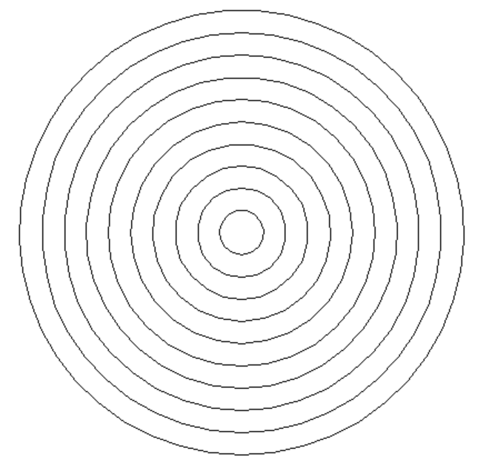

HINTS
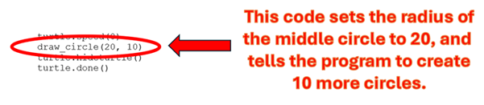
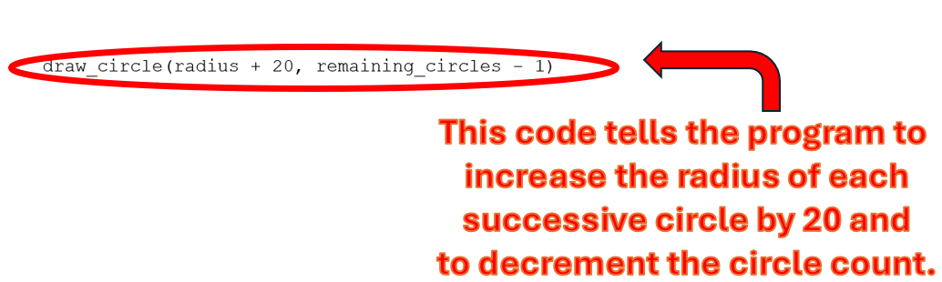

Please change the number of circles to 80, and the difference between each successive circle to 2 instead of 20. You should get the following:
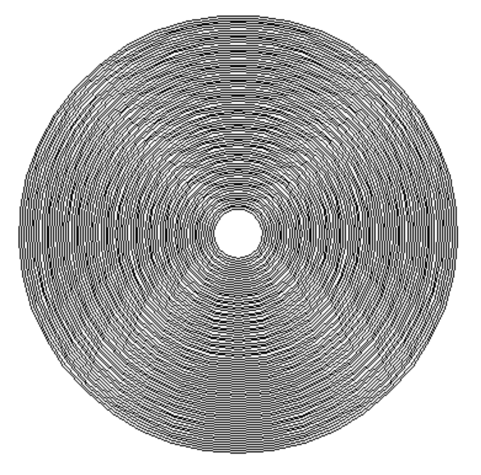

Submission:
Do a screengrab of the resultant images, as well as the code, and paste it all onto your Template document.

QUESTION 3
Instructions:
Explain the term aliasing in the context of image synthesis.

Submission:
- Please submit your definition into the Template Document.

Search in Brightspace for the following module: “Creative Coding CMPU1042: 2024-25” and please enroll.

e-mail me a completed solution to each of the above programs in your Template document. Send it to Damian.X.Gordon@tudublin.ie with subject heading “DT850 CC Lab #2”, and put it in Brightspace as well.

