Lab #3
TU850/1 - Creative Coding

Your working lab has to be shown to (and signed off by) the lab demonstrator between 12 noon and 2pm on Monday 10th of February, in CQ-233/CQ-236.
QUESTION 1
Instructions:
Take the following code and run it:
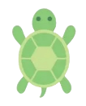 | Python with Turtle
import turtle
import math
# Screen setup
screen = turtle.Screen()
screen.bgcolor("pink")
screen.tracer(0)
# Create turtle objects
def create_turtle(shape, color, size, pos):
t = turtle.Turtle()
t.shape(shape)
t.color(color)
t.shapesize(*size)
t.penup()
t.goto(pos)
return t
# Eye properties
eye_radius = 50
pupil_radius = 15
eye_distance = 80
# Left eye
left_eye = create_turtle("circle", "white", (5, 5, 1), (-eye_distance, 0))
left_pupil = create_turtle("circle", "blue", (1.5, 1.5, 1), (-eye_distance, 0))
# Right eye
right_eye = create_turtle("circle", "white", (5, 5, 1), (eye_distance, 0))
right_pupil = create_turtle("circle", "blue", (1.5, 1.5, 1), (eye_distance, 0))
# Function to move pupils
def move_pupils(x, y):
for eye, pupil in [(left_eye, left_pupil), (right_eye, right_pupil)]:
ex, ey = eye.pos()
dx, dy = x - ex, y - ey
dist = math.sqrt(dx**2 + dy**2)
if dist > eye_radius - pupil_radius:
dx = dx / dist * (eye_radius - pupil_radius)
dy = dy / dist * (eye_radius - pupil_radius)
pupil.goto(ex + dx, ey + dy)
screen.update()
# Bind mouse movement
screen.listen()
screen.onscreenclick(move_pupils, 1) # Click to test movement
screen.ontimer(lambda: screen.update(), 10)
screen.mainloop()

Click on all four corners of the screen that is generated and screengrab each one:
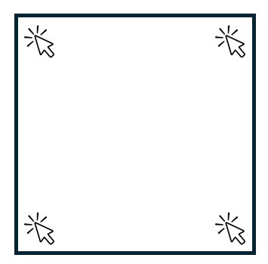
Submission:
Paste all four screengrabs onto your Template document.

QUESTION 2
Instructions:
Change the eyecolour of both eyes from blue to brown, and screengrab that result.
Submission:
Paste a screengrab and the new code onto your Template document.

QUESTION 3
Instructions:
Run the following code:
Python with Turtle
import turtle
import math
import random
import time
# Set up the screen
screen = turtle.Screen()
screen.bgcolor("black")
screen.setup(width=1.0, height=1.0) # Fullscreen mode
turtle.colormode(255) # Enable RGB colors
# Create a turtle for waves
t = turtle.Turtle()
t.speed(16) # Fast drawing
t.width(2)
t.hideturtle()
# Turtle for Pollock-style splots
splot_turtle = turtle.Turtle()
splot_turtle.hideturtle()
splot_turtle.speed(0)
# Fast screen updates for smooth rendering
turtle.tracer(6, 1)
# Define color sequence
wave_colors = [
(255, 0, 0), # Red
(255, 165, 0), # Orange
(255, 255, 0), # Yellow
(0, 255, 0), # Green
(148, 0, 211), # Violet
(0, 255, 0), # Green
(255, 255, 0), # Yellow
(255, 165, 0), # Orange
(255, 0, 0), # Red
(255, 165, 0), # Orange
(255, 255, 0), # Yellow
(0, 255, 0), # Green
(148, 0, 211), # Violet
(0, 255, 0), # Green
(255, 255, 0), # Yellow
(255, 165, 0) # Orange
]
# Function to draw Pollock-style paint splots
def draw_paint_splot(x, y, size, color, fade_steps=1):
size = int(size) # Ensure size is an integer
splot_turtle.color(color)
splot_turtle.width(2)
splot_turtle.penup()
splot_turtle.goto(x, y)
# Create a chaotic splatter effect with lines
for _ in range(random.randint(8, 15)):
angle = random.randint(0, 360)
length = random.randint(size // 2, size) # Ensure size is an integer
width = random.randint(2, 6)
splot_turtle.width(width)
splot_turtle.setheading(angle)
splot_turtle.pendown()
splot_turtle.forward(length)
splot_turtle.penup()
splot_turtle.goto(x, y)
# Add small random dots to mimic paint drips
for _ in range(random.randint(10, 20)):
dot_x = x + random.randint(-size // 2, size // 2)
dot_y = y + random.randint(-size // 2, size // 2)
dot_size = random.randint(2, 6)
splot_turtle.goto(dot_x, dot_y)
splot_turtle.dot(dot_size)
# Function to fade in a white splot
def fade_in_splot(x, y, max_size):
for step in range(1, 6): # 5 steps to fade in
draw_paint_splot(x, y, int(max_size * (step / 5)), "white") # Convert to int
time.sleep(0.2) # Delay between fade-in steps
screen.update()
# Function to draw densely packed sine waves across the full screen
def draw_fullscreen_dense_sine_waves(wave_count=180, amplitude=15, frequency=7):
screen_width = screen.window_width()
screen_height = screen.window_height()
x_start = -screen_width // 2
y_start = screen_height // 2
gap = screen_height / wave_count
black_splot_positions = []
for i in range(wave_count):
# Select the color based on the sequence (each color lasts for 5 waves)
t.pencolor(wave_colors[(i // 5) % len(wave_colors)])
t.penup()
t.goto(x_start, y_start - (i * gap))
t.pendown()
for j in range(screen_width):
y_offset = amplitude * math.sin(math.radians(j * frequency))
t.goto(x_start + j, y_start - (i * gap) + y_offset)
# Add a black splat every 10 waves
if i % 10 == 0:
black_x = random.randint(-screen_width // 2, screen_width // 2)
black_y = y_start - (i * gap) + random.randint(-20, 20)
draw_paint_splot(black_x, black_y, 80, "black")
black_splot_positions.append((black_x, black_y, i))
# After 5 waves, place a white splat at a random position with fade-in
for bx, by, wave_index in black_splot_positions:
if i == wave_index + 5:
white_x = random.randint(-screen_width // 2, screen_width // 2)
white_y = y_start - (i * gap) + random.randint(-30, 30)
fade_in_splot(white_x, white_y, 160)
# Draw full-screen sine waves with Pollock-style splots and fading white splots
draw_fullscreen_dense_sine_waves(wave_count=180, amplitude=15, frequency=7)
# Keep the window open
turtle.done()

WARNING: This should take at least a minute to fully draw, and you’ll need to use the complier installed on the machine you are using rather than one of the online compliers.
You should get something like this:
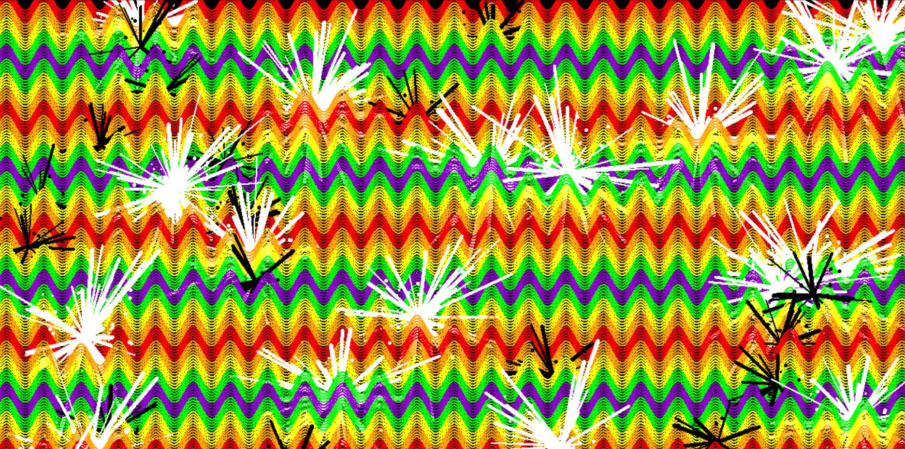

Do a screengrab of your result.
Please take your code and put it into ChatGPT and ask it to add a new feature into the code, whatever you like, it could be to add a new random shape, or a different colour splot at the end, or some user interactive feature. Explain the new feature in 50-100 words.
- Take the following code and add …:

Submission:
Submit the two screengrabs, as well as the code and the explaination, and paste it all onto your Template document.

Search in Brightspace for the following module: “Creative Coding CMPU1042: 2024-25” and please enroll.

e-mail me a completed solution to each of the above programs in your Template document. The Template document should be renamed as follows:
- Surname_Firstname_Student#__Lab3.pdf
- for example: Smith_John_D1234567_Lab3.pdf
Send it to Damian.X.Gordon@tudublin.ie with subject heading “DT850 CC Lab #3”, and put it in Brightspace as well.

