Lab #5

TU850/1 - Creative Coding

*You are welcome to submit this lab before Monday at 12 noon (and there’s no need to come into the lab), or during the lab before 2pm.*

**QUESTION 1**

|  |  |
| --- | --- |
| * **Piet Mondrian** (7th March 1872 – 1st February 1944) was a Dutch painter and art academic who is one of the greatest artists of the 20th century. * He was one of the pioneers of 20th-century abstract art, as he changed his artistic direction from figurative painting to an increasingly abstract style, until he reached a point where his artistic vocabulary was reduced to simple geometric elements. * He evolved a non-representational form which was called the new 'pure plastic art' which he believed was necessary in order to create 'universal beauty'. | Piet Mondrian - Wikipedia |

To express this “universal beauty”, Mondrian eventually decided to ***limit his formal vocabulary to the three primary colours (red, blue, and yellow), the three primary values (black, white, and grey), and the two primary directions (horizontal and vertical)***.

|  |  |  |
| --- | --- | --- |
| **Early work** |  | **Later work** |
| Piet Mondrian painting Spring Sun (Lentezon): Castle Ruin: Brederode in the Dallas Museum of Art |  | Piet Mondrian abstract painting Tableau I, from 1921 |
| Piet Mondrian painting Evening; Red Tree in the Gemeentemuseum Den Haag |  | Piet Mondrian abstract painting Composition II in Red, Blue, and Yellow, 1930 |

The **Processing 4** code below generates paintings in the style of Mondrian, so for this question, I want you to do two things:

1. Run the code three (3) times, and screengrab each one.
2. Now, change the following line of code: float minHeight = height / 4.0;

from 4.0 to both 2.0 and to 6.0, and run each one of those twice, and screengrab.

|  |  |
| --- | --- |
| Processing 4 | **Processing 4** |
| void setup() {  size(600, 600);  noLoop(); // Draw only once  }  void draw() {  background(255); // White background  **float minHeight = height / 4.0;** // Ensuring at least 4 rows  float y = 0;    for (int i = 0; i < 4; i++) {  float h = random(minHeight * 0.8, minHeight * 1.2); // Slight variation in row height  if (i == 3) h = height - y; // Ensure last row fits perfectly  drawRow(0, y, width, h);  y += h;  }  }  void drawRow(float x, float y, float w, float h) {  if (w > 80 && random(1) > 0.3) {  // Split into multiple columns within the row  float startX = x;  while (startX + 80 < x + w) { // Ensure minimum width of 80  float rectW = random(80, (x + w - startX) / 2);  if (startX + rectW > x + w - 80) rectW = x + w - startX; // Fit last column  drawRectangle(startX, y, rectW, h);  startX += rectW;  }  } else {  drawRectangle(x, y, w, h);  }  }  void drawRectangle(float x, float y, float w, float h) {  stroke(0);  strokeWeight(8);  fill(getMondrianColor());  rect(x, y, w, h);  }  color getMondrianColor() {  color[] palette = {color(255, 0, 0), color(0, 0, 255), color(255, 255, 0), color(255)};  return palette[int(random(palette.length))];  } | |

**QUESTION 2**

|  |  |
| --- | --- |
| * **Georges Seurat** (2nd December 1859 – 29th March 1891) was a French painter and is considered one of the greatest artists of the 20th century. * He devised several painting techniques, including pointillism which is a technique that relies on the ability of the eye and mind of the viewer to blend the colour spots into a fuller range of tones. * His art combines qualities that are usually thought of as opposed and incompatible: on the one hand, his extreme and delicate sensibility, on the other, a passion for logical abstraction and an almost mathematical precision of mind. | Georges Seurat |

His large-scale work “A Sunday Afternoon on the Island of La Grande Jatte” (1884–1886) changed the direction of modern art, and is one of the icons of late 19th-century painting.

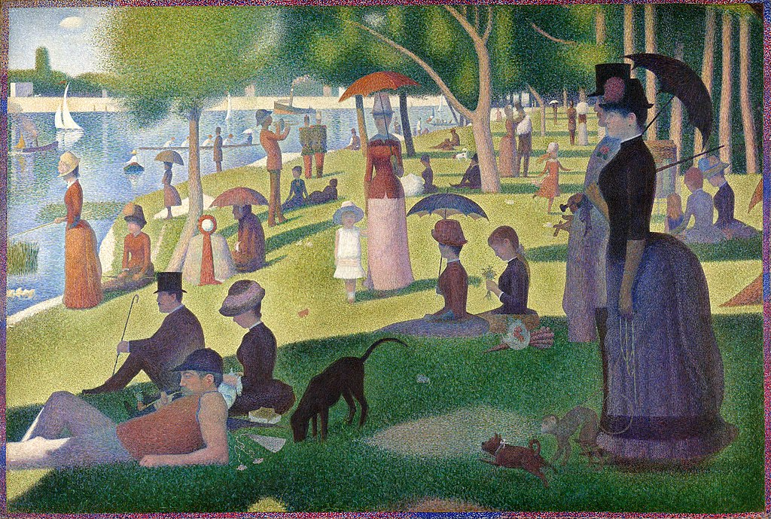

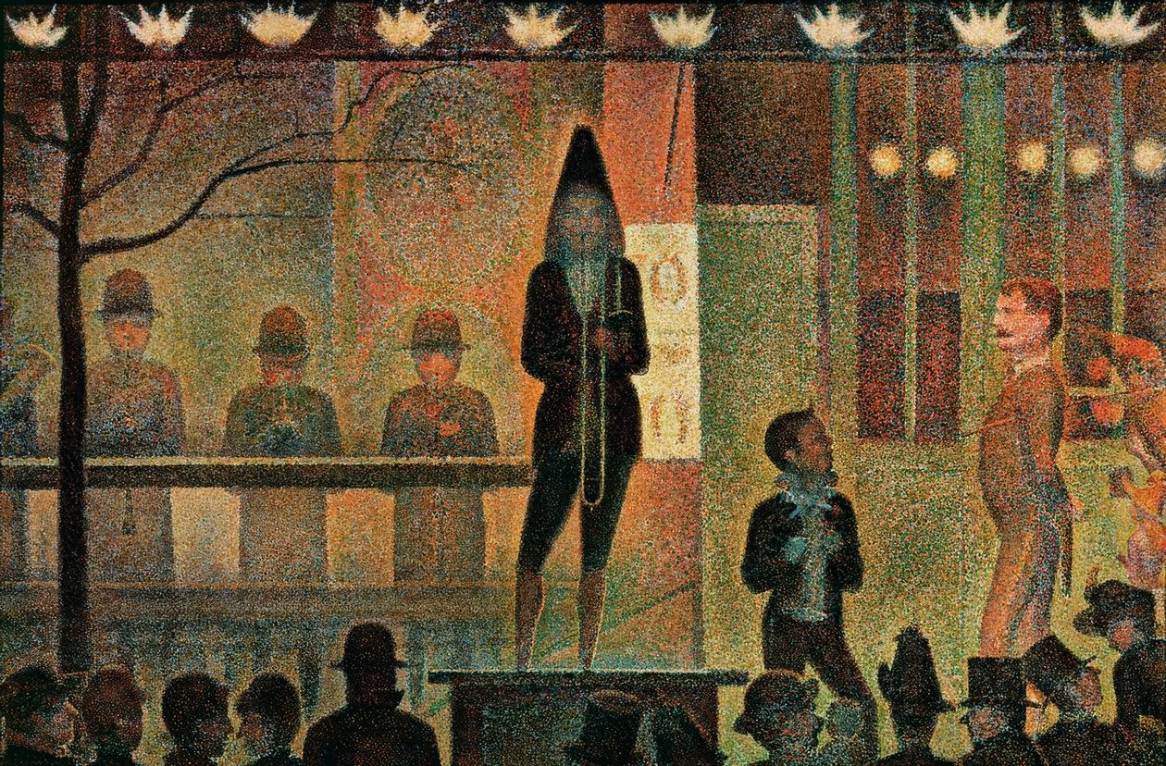

|  |  |  |
| --- | --- | --- |
| Let’s try to draw one of the trees from “A Sunday Afternoon”, pictured here, using this point-by-point technique.   * So, here’s the code in **Processing 4**, run it once, and do a screengrab of it. * Now change the 0.55 on the fourth line below, first to 0.45 and then to 0.65, and screengrab those. | |  |
| Processing 4 | **Processing 4** | |
| void setup() {  size(400, 400);  background(255);  drawPointillistTree(width * 0.5, **height * 0.55**);  }  void drawPointillistTree(float x, float y) {  int numDots = 24000; // doubled for density  float trunkWidth = 50; // doubled  float trunkHeight = 120; // doubled  float foliageRadius = 140; // doubled  // Draw trunk with texture  for (int i = 0; i < numDots / 4; i++) {  float px = x + random(-trunkWidth / 2, trunkWidth / 2);  float py = y + random(0, trunkHeight);  stroke(120 + random(-30, 30), 60 + random(-20, 20), 20);  point(px, py);  }  // Draw foliage above the trunk  for (int i = 0; i < numDots; i++) {  float angle = random(TWO_PI);  float radius = sqrt(random(0, 1)) * foliageRadius;  float px = x + radius * cos(angle);  float py = y - trunkHeight + radius * sin(angle);  stroke(getSeuratTreeColor(px, py));  point(px, py);  }  }  color getSeuratTreeColor(float x, float y) {  float noiseValue = noise(x * 0.02, y * 0.02);  if (noiseValue < 0.2) {  return color(20, 100, 20); // Dark green shadows  } else if (noiseValue < 0.5) {  return color(34, 139, 34); // Rich green  } else if (noiseValue < 0.8) {  return color(50, 205, 50); // Medium green  } else {  return color(173, 255, 47); // Bright highlights  }  } | | |

**QUESTION 3**

|  |  |
| --- | --- |
| * **Pablo Picasso** (25th October 1881 – 8th April 1973) was a Spanish painter, sculptor, printmaker, ceramicist, and theatre designer who spent most of his adult life in France. * One of the most influential artists of the 20th century, he is known for co-founding the Cubist movement, the invention of constructed sculpture, the co-invention of collage, and for the wide variety of styles that he helped develop and explore. * Among his most famous works is the anti-war painting *Guernica* (1937), a dramatic portrayal of the bombing of Guernica by German and Italian air forces during the Spanish Civil War. |  |

Picasso didn’t think of his work as evolving linearly, instead he use whichever technique suited the subject of his painting: "*The several manners I have used in my art must not be considered as an evolution, or as steps towards an unknown ideal of painting ... If the subjects I have wanted to express have suggested different ways of expression I have never hesitated to adopt them*."

|  |  |  |
| --- | --- | --- |
| Don Quixote (Picasso) - Wikipedia | Pablo Picasso's Child with a Dove to ... | Self Portrait, 1901 by Picasso |

***Guernica***

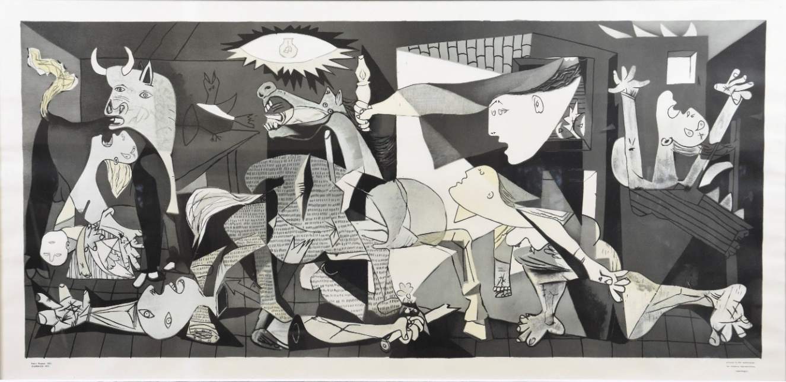

The **Processing 4** code below generates images in the style of Guernica, I just want you to run this program twice, and screengrab the outputs (they will be very similar to each other).

|  |  |
| --- | --- |
| Processing 4 | **Processing 4** |
| void setup() {  size(1200, 500);  background(255);  noLoop(); // Only draw once  }  void draw() {  drawGuernicaAbstract();  }  void drawGuernicaAbstract() {  noStroke();  // Background sections with random brightness variations  fill(random(30, 70)); rect(0, 0, width/3, height);  fill(random(80, 120)); rect(width/3, 0, width/3, height);  fill(random(150, 220)); rect(2 * width/3, 0, width/3, height);  // Abstract face (randomized position)  fill(0);  triangle(random(250, 350), random(50, 150),  random(300, 400), random(250, 350),  random(180, 250), random(200, 300));  // Abstract body with slight randomness  triangle(random(480, 520), random(80, 120),  random(620, 680), random(250, 350),  random(480, 520), random(350, 450));  // White contrast shapes  fill(255);  ellipse(random(700, 800), random(150, 250), 100, 150); // Eye or face  ellipse(random(850, 950), random(250, 350), 80, 120); // Another figure    // Abstract details  fill(0);  rect(random(580, 620), random(220, 280), 120, 60);  rect(random(780, 820), random(380, 420), 50, 100);  // Jagged fragmented shape with random points  fill(100);  beginShape();  for (int i = 0; i < 5; i++) {  vertex(random(50, 300), random(300, 450));  }  endShape(CLOSE);  // Lightbulb motif with randomized size  fill(255);  float bulbSize = random(50, 80);  ellipse(950, 80, bulbSize, bulbSize);  fill(0);  triangle(940, 60, 960, 60, 950, 40);  // Stylized "screaming mouth" with randomized teeth  fill(255);  arc(500, 350, 80, 40, 0, PI);  fill(0);  for (int i = 0; i < 4; i++) {  rect(470 + (i * 15), 340, random(5, 10), 5); // Random width for teeth  }  // Random jagged chaos lines  stroke(0);  strokeWeight(3);  for (int i = 0; i < 5; i++) {  line(random(100, 900), random(50, 450), random(100, 900), random(50, 450));  }  } | |

**Submission:**

Submit the screengrabs, and paste it all onto your Template document.

|  |
| --- |
| e-mail me a completed solution to each of the above programs in your Template document. The Template document should be renamed as follows:   * Surname_Firstname_Student#__Lab5.pdf * for example: Smith_John_D1234567_Lab5.pdf   Send it to [Damian.X.Gordon@tudublin.ie](mailto:Damian.X.Gordon@tudublin.ie) with subject heading “DT850 CC Lab #5”, and put it in Brightspace as well. |

You should be able to fit it in all two pages, like this:

