Lab #6
TU850/1 - Creative Coding

You are welcome to submit this lab before Monday at 12 noon (and there’s no need to come into the lab), or during the lab before 2pm.
Please fill out the attached template where you will describe the work you undertook in doing Assignment #1. Additionally change all of the text that is in RED into BLACK. Here’s what you have to do:
- Section 1.1: Leave it exactly as it is.
- Section 1.2: Add in whichever generative AI tool you used, and if you didn’t use one, just delete that bullet point.
- Section 1.3: Leave it exactly as it is.

- Section 2.X: For all of the subsections in Section 2, post the image you generated from Assignment 1. Get rid of all the white boundary around the image you created, as demonstrated below:
 | 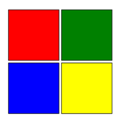 |  | 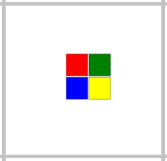
 |  |  | 

Each section asks how long it took you to draw the figures, don’t worry too much, just a rough guess is fine.
If you used Generative AI, write down 1 or 2 prompts you used for that diagram (it doesn’t have to be the exact prompt, just a reasonable representation of the prompt is fine). Then add a few sentences on what changes you had to make to the code.
If you didn’t use Generative AI, just describe in a few sentences how you created the code, and what was tricky about it.

- Section 3.1: Mention which figures were most tricky in terms of alignment, and in terms of colour matching.
- Section 3.2: Leave it exactly as it is.

Submission:
Submit the two screengrabs, as well as the code and the explanation, and paste it all onto your Template document.

Search in Brightspace for the following module: “Creative Coding CMPU1042: 2024-25” and please enroll.

e-mail me a completed solution to each of the above programs in your Template document. The Template document should be renamed as follows:
- Surname_Firstname_Student#__Lab6.pdf
- for example: Smith_John_D1234567_Lab6.pdf
Send it to Damian.X.Gordon@tudublin.ie with subject heading “DT850 CC Lab #6”, and put it in Brightspace as well.

