Lab #1
Operating Systems 1
Instructions:
1. Read the problem carefully on the following page
2. Read it again
3. Figure out a rough ordering of items

4. Chat with 3 or 4 classmates discuss for about 15 minutes the correct ordering of these items (include the list of people’s names you spoke to in your submission).

5. Settle on a final ordering of these items for yourself

6. Create a new blog by going to the website http://www.blogger.com and create a blog with the following naming (replacing my name with yours):
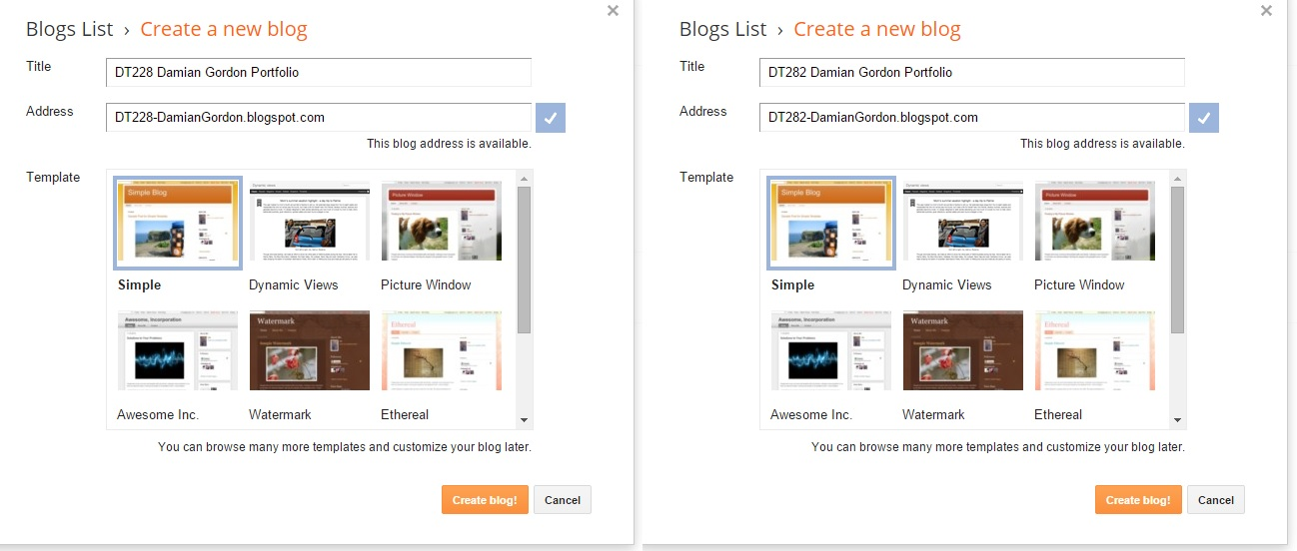
Title: DT2XX Damian Gordon Portfolio
Address: DT2XX-DamianGordon.blogspot.com

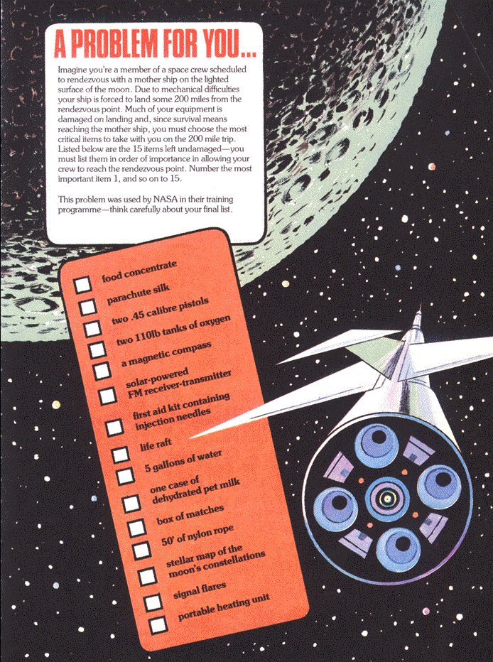

7. Post the listing of the items, with a reason for each item’s position in the list to the blog, and who you spoke to.

8. Go to the following web address:
http://vark-learn.com/the-vark-questionnaire/
Answer all the quiz questions and click “OK”
Copy all of the text from the following page into the email you are going to send me in Step 9 (please do not post this to your blog).

9. e-mail your blog address to Damian.Gordon@dit.ie with a subject heading of OPERATING SYSTEMS 1 LAB #1 and in the message of your e-mail please let me know your full name, your student number, the name of your programme, the programme code, the name of the module, the year you are in (first year), the result of your VARK questionnaire, and your assignment website address (make sure you email me the BLOGSPOT address, not the BLOGGER one, and the address of page, not of the Preview page).

Marking: Please note, this lab is due for submission by the end of your lab session. As long as you have a ranking beside each item, and any reason you want why you've put it there for each one, and who you spoke to in a blog post, you'll get full marks for this first lab. NOTE: Subsequent labs will not be marked unless this one is completed.
The labs contributes to 40% of your final result in the continuous assessment for this module, so it's best to get the earlier ones done as well as you can, because as the labs continue on they will get harder, so you might as well pick up the easy marks early on.

