Lab #2
Operating Systems 1
Instructions:
1. Read the lab carefully on the following pages
2. Read it again
3. Log onto a computer
4. Click the START button on the bottom left corner of your screen
5. Type ‘cmd’ into the command bar
6. You should get this:

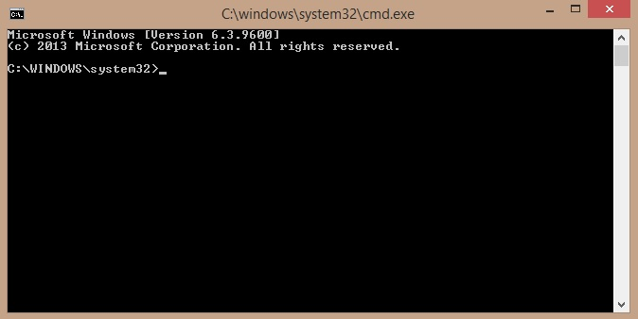

7. Type in each of the below commands, and do a screengrab the outputs, and if the output of a command exceeds the length of the screen, don’t worry about it, just do a screengrab of whatever is on screen at the end, e.g:

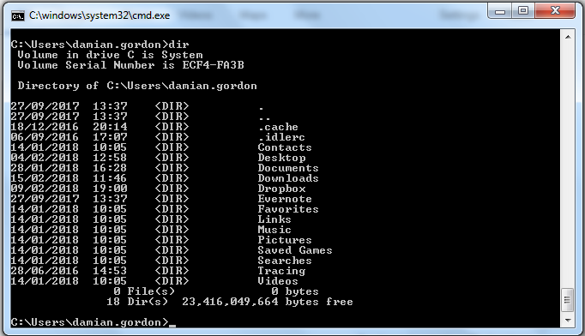
- dir (pronounced: “dir”)
  - this command lists all the files in the current folder

- help (pronounced: “help”)
  - this command lists all the commands and tell you what they do

- cls (pronounced: “see el ess”)
  - this command clears the screen

- path (pronounced: “path”)
  - this command tells you where all folder to look for software

- cd .. (pronounced: “see dee space dot dot”)
  - Moves you from your current folder to the containing folder

- tree (pronounced: “tree”)
  - presents a visual display of all of the folders in the sytem

8. Create a new post on your blog called “Operating Systems 1 Lab 2 – DOS Commands” and insert all of the explanations and screengrabs into your blog.

9. Whatever title you put on the blog posting for lab 1, change it to
“Operating Systems 1 Lab 1”

10. e-mail your blog address to Damian.Gordon@dit.ie with a subject heading of OPERATING SYSTEMS 1 LAB #2 and in the message of your e-mail please let me know your full name, your student number, the name of your programme, the programme code, the name of the module, the year you are in (first year), and your assignment website address. Make sure you include a salutation and a sign-off.

Marking: NOTE: Subsequent labs will not be marked unless this one is completed. The labs contributes to 40% of your final result in the continuous assessment for this module, so it's best to get the earlier ones done as well as you can, because as the labs continue on they will get harder, so you might as well pick up the easy marks early on.

