Lab #3
Operating Systems 1
Instructions:
1. Read the problem carefully on the following pages
2. Read it again
3. Log onto a computer
4. Using Notepad create a file called ReallyImportantProgram1.txt
5. Put the following text into the file
This is a really important program
6. Do a screengrab of it.
7. Using Notepad create a second file called ReallyImportantProgram2.txt with the same text in it as ReallyImportantProgram1.txt
8. Do a screengrab of it.
9. Using Notepad create a file called MakeABackup.bat
10. IMPORTANT: When creating this file, do not save it as a .TXT file, save it as “ALL FILES”
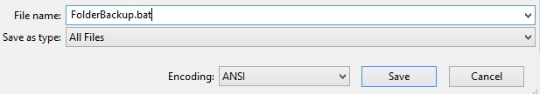
11. In this file put in the following text
mkdir BackupFolder
copy ReallyImportant*.txt BackupFolder
dir BackupFolder
12. Do a screengrab of it.

13. Click the START button on the bottom left corner
14. Type ‘cmd’ into the command bar
15. You should get this:
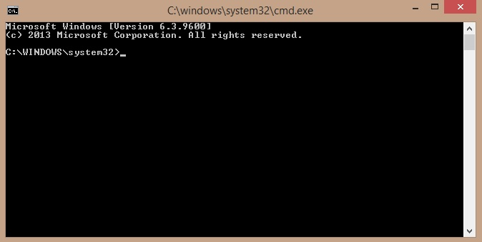

16. Using the CD command, get to the folder that has all of the above commands in it (You might be there already, or you might have to do: cd ../../Users/<YourID>/Desktop).
17. Type in MakeABackup
18. Do a screengrab of what you get.
19. Create a new post on your blog called Operating Systems 1 Lab 4 – DOS Batch File Creation and insert all of the screengrabs into the blog, and add a sentence (at least 30 words) at the end saying what you think you just did.

20. e-mail your blog address to Damian.Gordon@dit.ie with an email subject heading of OPERATING SYSTEMS 1 LAB #3 and in the message of your e-mail please let me know your full name, your student number, the name of your programme, the programme code, the name of the module, the year you are in (first year), and your assignment website address. Make sure you include a salutation and a sign-off.

Marking: Please note, the labs contributes to 40% of your final result in the continuous assessment for this module, so it's best to get the earlier ones done as well as you can, because as the labs continue on they will get harder, so you might as well pick up the easy marks early on.

