Lab #4
Operating Systems 1
Instructions:
1. Read the problem carefully on the following pages
2. Read it again
3. Log onto a computer

4. Following on from lab #3, go into DOS and find the folder you created the BATCH file and the two ReallyImportantProgram files (we’ll call this your LabFolder).

5. Create a sub-folder in there called Folder1.
6. Go into that folder ($ cd Folder1)
7. Create a copy of ReallyImportantProgram1.txt in this folder called ReallyImportantProgram3.txt
$ copy ..\ ReallyImportantProgram1.txt .\ReallyImportantProgram3.txt

8. Check the path variable ($ path)
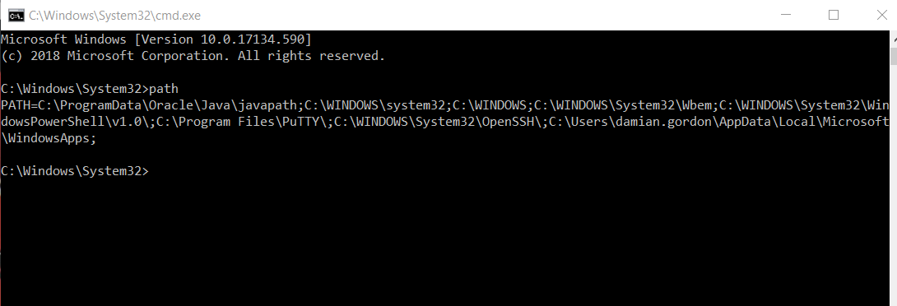

9. Add your LabFolder to the PATH variable ($ path=%PATH%;NewAddress)
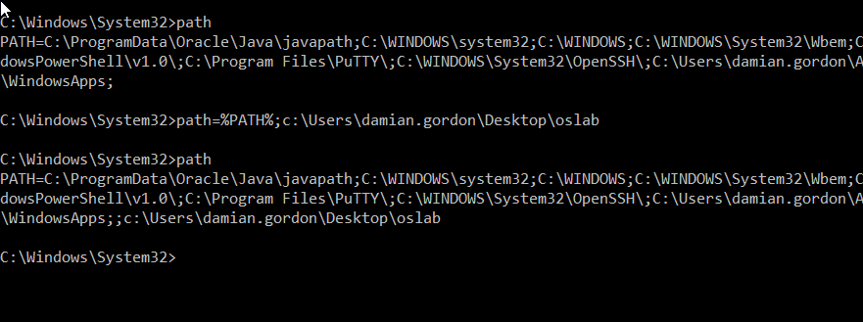
10. Type in MakeABackup
11. Do a screengrab of what you get.
12. Create a new post on your blog called Operating Systems 1 Lab 4 – Setting a Path and insert all of the screengrabs into the blog, and add a sentence (at least 30 words) at the end saying what you think you just did.
13. Change the title of last week’s blog post to Operating Systems 1 Lab 3 – DOS Batch File Creation.

14. e-mail your blog address to Damian.Gordon@dit.ie with an email subject heading of OPERATING SYSTEMS 1 LAB #4 and in the message of your e-mail please let me know your full name, your student number, the name of your programme, the programme code, the name of the module, the year you are in (first year), and your assignment website address. Make sure you include a salutation and a sign-off.

Marking: The labs contributes to 40% of your final result in the continuous assessment for this module, so it's best to get the earlier ones done as well as you can, because as the labs continue on they will get harder, so you might as well pick up the easy marks early on.

