Lab #5
Operating Systems 1
Instructions:
1. Read the problem carefully on the following pages
2. Read it again
3. Create a File called MyMenu.bat with the following text:
ECHO OFF
CLS
:MENU
ECHO.
ECHO ...............................................
ECHO PRESS 1, 2 OR 3 to select your task, or 4 to EXIT.
ECHO ...............................................
ECHO.
ECHO 1 - Open Notepad
ECHO 2 - Open Calculator
ECHO 3 - Open Notepad AND Calculator
ECHO 4 - EXIT
ECHO.
SET /P M=Type 1, 2, 3, or 4 then press ENTER:
IF %M%==1 GOTO NOTE
IF %M%==2 GOTO CALC
IF %M%==3 GOTO BOTH
IF %M%==4 GOTO EOF
:NOTE
cd %windir%\system32\notepad.exe
start notepad.exe
GOTO MENU
:CALC
cd %windir%\system32\calc.exe
start calc.exe
GOTO MENU
:BOTH
cd %windir%\system32\notepad.exe
start notepad.exe
cd %windir%\system32\calc.exe
start calc.exe
GOTO MENU
:EOF

4. Check the path variable ($ path) – and screengrab it.
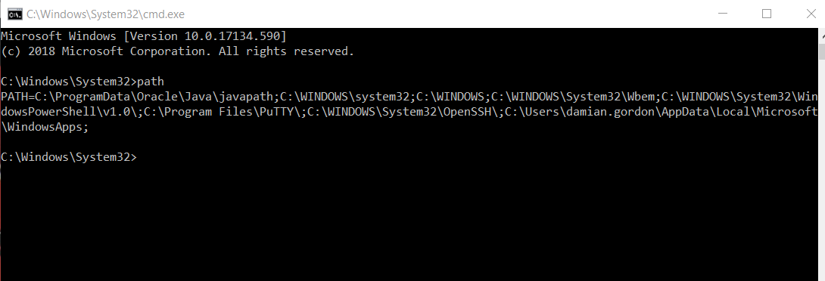
5. Add the location of MyMenu.bat to the PATH variable ($ path=%PATH%;NewAddr) – and screengrab it.
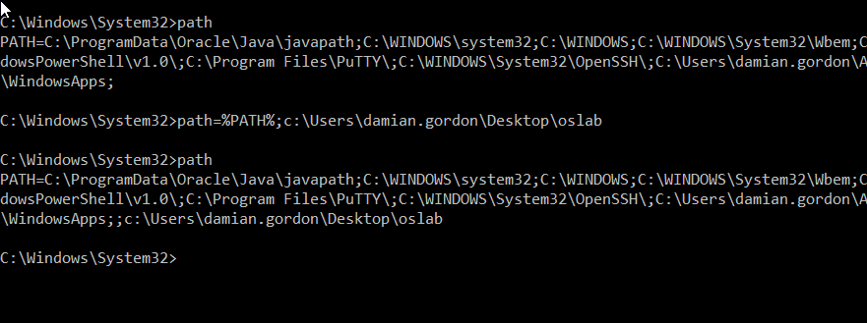
6. Type in MyMenu from a location other than where it is stored
7. Do a screengrab of what you get when you select options 1,2,3 and 4.
8. Create a new post on your blog called Operating Systems 1 Lab 5 – Creating a Menu and insert all of the screengrabs into the blog, and add a sentence (at least 30 words) at the end saying what you think you just did.

9. e-mail your blog address to Damian.Gordon@dit.ie with an email subject heading of OPERATING SYSTEMS 1 LAB #5 and in the message of your e-mail please let me know your full name, your student number, the name of your programme, the programme code, the name of the module, the year you are in (first year), and your assignment website address. Make sure you include a salutation and a sign-off.
Marking: The labs contributes to 40% of your final result in the continuous assessment for this module, so it's best to get the earlier ones done as well as you can, because as the labs continue on they will get harder, so you might as well pick up the easy marks early on.

