Try this, please
Operating Systems 1
Instructions:
1. If you are doing this on a DIT computer, there should be a program on the desktop called PuTTY, run it.
2. You should get a screen like this:
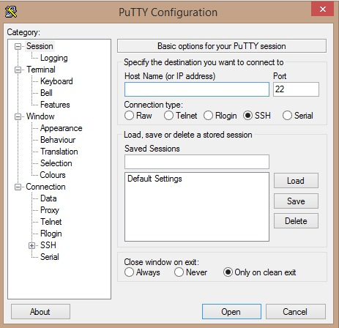

3. In the field “Host Name (or IP address)”, type in:
147.252.234.34

4. It should look like:
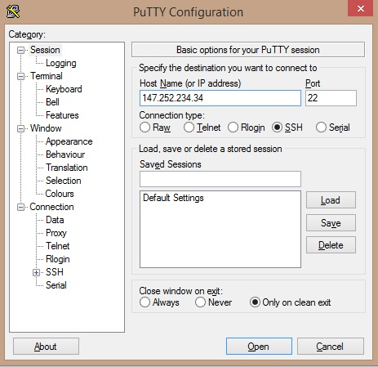

5. This will bring you to a black login screen, use your standard ictdomain username and password to login.

16. Type “ls –la”
17. Type “logout”

