Sustainable Data Science and Artificial Intelligence

Tutorial #6
Instructions
The following C code is for a neural network that learns the to convert BINARY into DECIMAL, as follows:
[0, 0, 0] 0 | [0, 0, 1] 1 | [0, 1, 0] 2 | [0, 1, 1] 3
[1, 0, 0] 4 | [1, 0, 1] 5 | [1, 1, 0] 6 | [1, 1, 1] 7

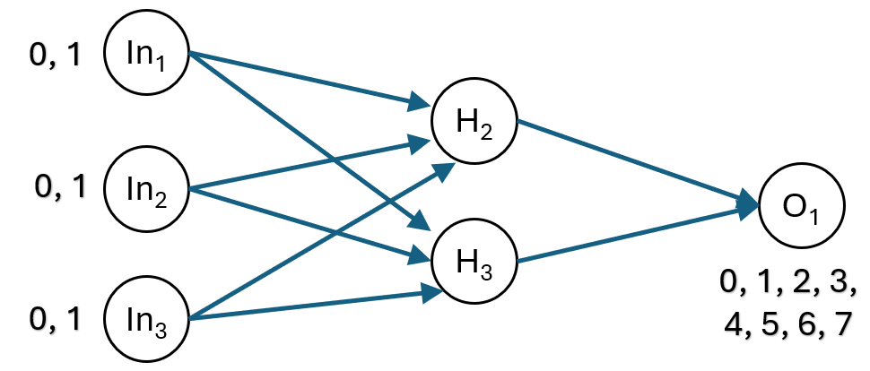
The key hyperparameter (LEARNING_RATE) are defined near the top as follows:

C Programming Language
#include <stdio.h>
#include <stdlib.h>
#include <math.h>
#include <time.h>

// Hyperparameters
#define LEARNING_RATE 0.5
#define EPOCHS 10000

// Activation function (Sigmoid)
double sigmoid(double x) {
return 1 / (1 + exp(-x));
}

// Derivative of sigmoid
double sigmoid_derivative(double x) {
return x * (1 - x);
}

// Random number generator for weight initialization
double random_weight() {
return ((double)rand() / RAND_MAX) * 2 - 1; // Range [-1, 1]
}

int main() {
srand(time(NULL)); // Seed random generator

// Training data: 3-bit binary input and its decimal equivalent (normalized)
double input[8][3] = {
{0, 0, 0}, {0, 0, 1}, {0, 1, 0}, {0, 1, 1},
{1, 0, 0}, {1, 0, 1}, {1, 1, 0}, {1, 1, 1}
};
double expected_output[8];
for (int i = 0; i < 8; i++) {
expected_output[i] = i / 7.0; // Normalize output (0 to 1)
}

// Initialize weights and biases randomly
double hidden_weights[3][2], hidden_bias[2];
double output_weights[2], output_bias;

// Random weight initialization
for (int i = 0; i < 3; i++)
for (int j = 0; j < 2; j++)
hidden_weights[i][j] = random_weight();

for (int j = 0; j < 2; j++)
hidden_bias[j] = random_weight();

for (int k = 0; k < 2; k++)
output_weights[k] = random_weight();

output_bias = random_weight();

// Training loop
for (int epoch = 0; epoch < EPOCHS; epoch++) {
double total_error = 0;

for (int i = 0; i < 8; i++) {
// Forward pass: Hidden Layer
double hidden_output[2];
for (int j = 0; j < 2; j++) {
hidden_output[j] = sigmoid(
input[i][0] * hidden_weights[0][j] +
input[i][1] * hidden_weights[1][j] +
input[i][2] * hidden_weights[2][j] +
hidden_bias[j]
);
}

// Forward pass: Output Layer
double output = sigmoid(
hidden_output[0] * output_weights[0] +
hidden_output[1] * output_weights[1] +
output_bias
);

// Compute error
double error = expected_output[i] - output;
total_error += error * error;

// Backpropagation: Output Layer
double output_delta = error * sigmoid_derivative(output);

// Backpropagation: Hidden Layer
double hidden_delta[2];
for (int j = 0; j < 2; j++) {
hidden_delta[j] = output_delta * output_weights[j] * sigmoid_derivative(hidden_output[j]);
}

// Update weights and biases (Gradient Descent)
for (int j = 0; j < 2; j++) {
output_weights[j] += LEARNING_RATE * output_delta * hidden_output[j];
hidden_bias[j] += LEARNING_RATE * hidden_delta[j];
}
output_bias += LEARNING_RATE * output_delta;

for (int j = 0; j < 2; j++) {
for (int m = 0; m < 3; m++) {
hidden_weights[m][j] += LEARNING_RATE * hidden_delta[j] * input[i][m];
}
}
}
}

// Testing the trained network
printf("\nTesting the trained neural network:\n");
for (int i = 0; i < 8; i++) {
double hidden_output[2];

// Forward pass - Hidden Layer
for (int j = 0; j < 2; j++) {
hidden_output[j] = sigmoid(
input[i][0] * hidden_weights[0][j] +
input[i][1] * hidden_weights[1][j] +
input[i][2] * hidden_weights[2][j] +
hidden_bias[j]
);
}

// Forward pass - Output Layer
double output = sigmoid(
hidden_output[0] * output_weights[0] +
hidden_output[1] * output_weights[1] +
output_bias
);

printf("Input: (%.0f, %.0f, %.0f) -> Output: %.2f (Expected: %.0f)\n",
input[i][0], input[i][1], input[i][2], output * 7, expected_output[i] * 7);
}

return 0;
}

Set the LEARNING_RATE to the following values:
10, 11, 12, 13, 14, 15, 16, 17, 18, 19, 20

For example, at learning rate 10:
Learning_Rate | Outputs
10 | Testing the trained neural network:  Input: (0, 0, 0) -> Output: 0.02 (Expected: 0)  Input: (0, 0, 1) -> Output: 1.01 (Expected: 1)  Input: (0, 1, 0) -> Output: 2.02 (Expected: 2)  Input: (0, 1, 1) -> Output: 3.01 (Expected: 3)  Input: (1, 0, 0) -> Output: 4.01 (Expected: 4)  Input: (1, 0, 1) -> Output: 5.04 (Expected: 5)  Input: (1, 1, 0) -> Output: 6.01 (Expected: 6)  Input: (1, 1, 1) -> Output: 6.98 (Expected: 7)

- Identify which settings give you the closest to the right answer.
- If the best setting is N, then test N – 0.5. and N + 0.5

Submission Instructions
Please submit in the following two ways
Please e-mail me your completed solution, and with filename:
Familyname_FirstName_TU850_1_SDSaAI_Tutorial6.docx
e.g.
Gordon_Damian_TU850_1_SDSaAI_ Tutorial6.docx
e-mail to Damian.X.Gordon@TUDublin.ie with subject heading as follows:
[DT850/1] SDSaAI Tutorial #6

Please submit into Brightspace in:
- Assessment
  - Assignments
    - Tutorial #6

For the email, please include the following message:
Damian,

I am a student in your Sustainable DS & AI (CMPU1040) class in the BSc in DS & AI (DT850/1).

Please find attached Tutorial #6

Regards,
Your Name
Student Number.
DT580, BSc in DS & AI

