Sustainable Data Science

and Artificial Intelligence

Activity #2

**Instructions**

|  |
| --- |
| 1. Read the problem carefully on the following page  2. Read it again |
| 3. Settle on a final ordering of these items for yourself |
| 4. e-mail me a completed solution, with the order and a few words after each item as to why you put it in the order you did. |

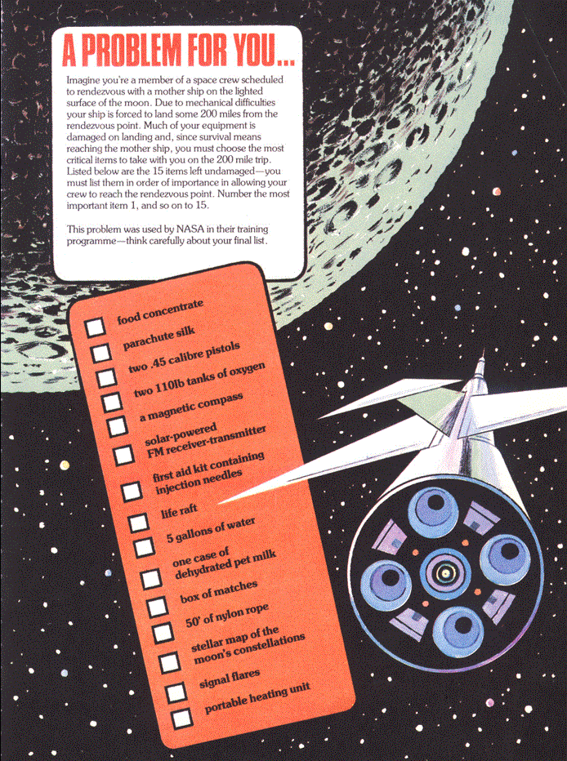

**Submission Instructions**

Please submit in the following two ways

|  |
| --- |
| Please e-mail me your completed solution, and with filename:  *Familyname_FirstName_TU850_1_SDSaAI_Activity2.docx*  e.g.  *Gordon_Damian_TU850_1_SDSaAI_Activity2.docx*  Also include the answer to Activity #1 in a separate file.  e-mail to [Damian.X.Gordon@TUDublin.ie](mailto:Damian.X.Gordon@TUDublin.ie) with subject heading as follows:  [DT850/1] SDSaAI Activity #1-2 |
| Please submit into Brightspace in:   * Assessment   + Assignments     - Activity #1 |

For the email, please include the following message:

|  |
| --- |
| **Damian,**  **I am a student in your Sustainable DS & AI (CMPU1040) class in the BSc in DS & AI (DT850/1).**    **Please find attached Activity #1-2.**  **Regards,**  **Your Name**  **Student Number.**  **DT580, BSc in DS & AI** |