Sustainable Data Science

and Artificial Intelligence

Activity #3
Instructions
1. Open Excel
2. Type in your student number into cells B3 to B11 as follows:
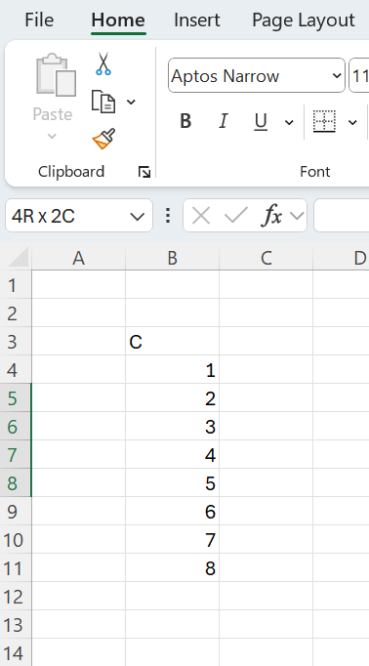

Into cell D5 type in =SUM(B4:B7):
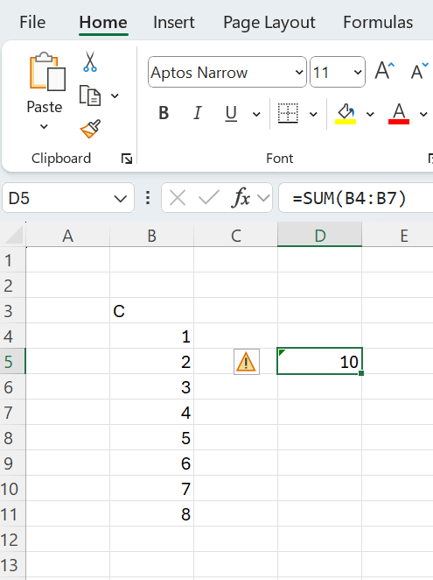

Into cell D9 type in =SUM(B8:B11):
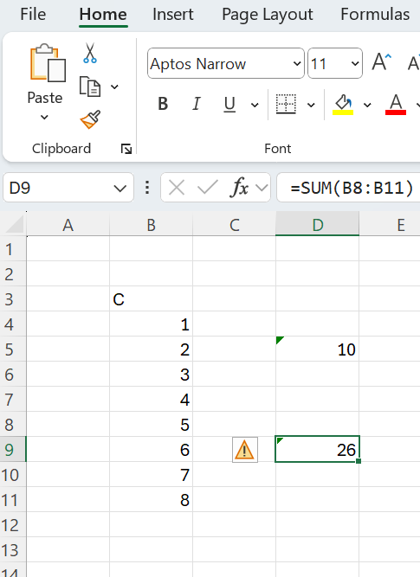
Into cell F7 type in =SUM(D5 + D9):
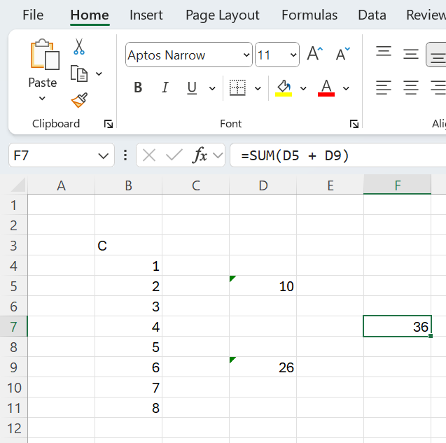

Do a screengrab of that and put it in the answer template.

Submission Instructions
Please submit in the following two ways
Please e-mail me your completed solution, and with filename:
Familyname_FirstName_TU850_1_SDSaAI_Activity3.docx
e.g.
Gordon_Damian_TU850_1_SDSaAI_Activity3.docx
Also include the answer to Activity #1 and Activity #2 in separate files.
e-mail to Damian.X.Gordon@TUDublin.ie with subject heading as follows:
[DT850/1] SDSaAI Activity #1-3

Please submit into Brightspace in:
- Assessment
  - Assignments
    - Activity #3

For the email, please include the following message:

Damian,

I am a student in your Sustainable DS & AI (CMPU1040) class in the BSc in DS & AI (DT850/1).

Please find attached Activity #1-3.

Regards,
Your Name
Student Number.
DT580, BSc in DS & AI

