Sustainable Data Science

and Artificial Intelligence

Activity #4
Instructions
1. In Excel, type the following values into the following cells:
B2 | Input
B4 | 1
B5 | 1
B6 | 0
B7 | 0
B8 | 1
B9 | 1
D4 | =IF((B4=B5), "Same", "NotSame")
D6 | =IF((B6=B7), "Same", "NotSame")
D8 | =IF((B8=B9), "Same", "NotSame")
F2 | Output
F6 | =IF(AND((D4=D6),(D6=D8)), "All Match", "Not All Match")
It should look something like this (if you want to you can add in the lines and the shading I have put in, please do):
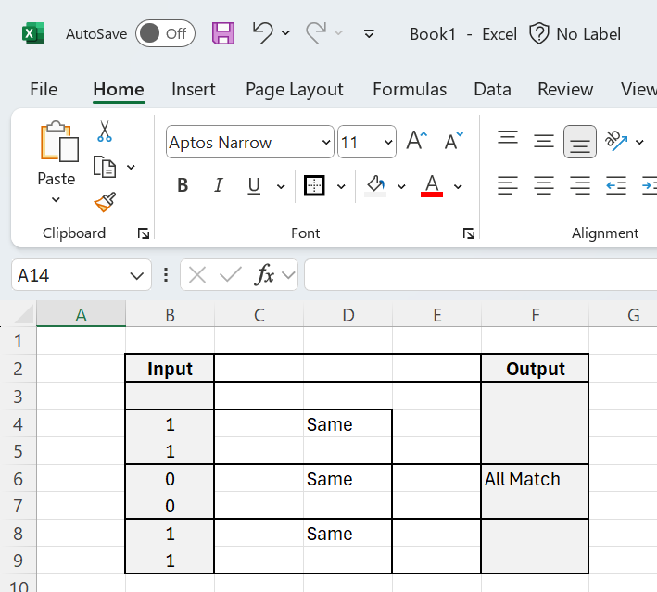
Do a screengrab of that and put it in the answer template.

Submission Instructions
Please submit in the following two ways
Please e-mail me your completed solution, and with filename:
Familyname_FirstName_TU850_1_SDSaAI_Activity4.docx
e.g.
Gordon_Damian_TU850_1_SDSaAI_Activity4.docx
Also include the answer to Activity #1-3 in separate files.
e-mail to Damian.X.Gordon@TUDublin.ie with subject heading as follows:
[DT850/1] SDSaAI Activity #1-4

Please submit into Brightspace in:
- Assessment
  - Assignments
    - Activity #4

For the email, please include the following message:
Damian,

I am a student in your Sustainable DS & AI (CMPU1040) class in the BSc in DS & AI (DT850/1).

Please find attached Activity #1-4.

Regards,
Your Name
Student Number.
DT580, BSc in DS & AI

