Sustainable Data Science

and Artificial Intelligence

Activity #5
Instructions
1. In Excel, type the following values into the following cells:
B6 | Seizure
B7 | Aphasia
B8 | Cognitive Issues
B7 | Aphasia
C2 | HOUSE, Season 1, Episode 1
C5 | Symptoms
C6 | 0
C7 | 1
C8 | 0
D6 | CAT Scan
D7 | MRI
E5 | Initial Tests
E6 | 0
E7 | 1
F6 | Thiamine Level
F7 | Contrast MRI
G5 | Follow up Tests
G6 | 0
G7 | 1
H6 | Brain tumour
H7 | Brain lesion
H8 | Aneurysm
H9 | Stroke
H10 | Ischemic syndrome
H11 | Creutzfeldt–Jakob disease
H12 | Wernicke encephalopathy
H13 | Cerebral vasculitus
I5 | Likely Diagnosis
I6 | =IF(AND((C6=1),(G6=1)), "Do another contrast MRI", "No")
I7 | =IF(AND((C7=1),(G6=1)), " Inject gadolinium", "No")
I8 | =IF(AND((C7=1),(E6=1)), " Check protein markers", "No")
I9 | =IF(AND((C8=1),(E6=1)), " Check SED rate", "No")
I10 | =IF(AND((C7=1),(E7=1)), " Give blood thinners", "No")
I11 | =IF(AND((C6=1),(E7=1)), " Test with interferon", "No")
I12 | =IF(AND((C6=1),(E6=1)), "Change diet", "No")
I13 | =IF(AND((C8=1),(E6=1)), " Use immunosuppressants", "No")
It should look something like this (if you want to you can add in the lines and the shading I have put in, please do):
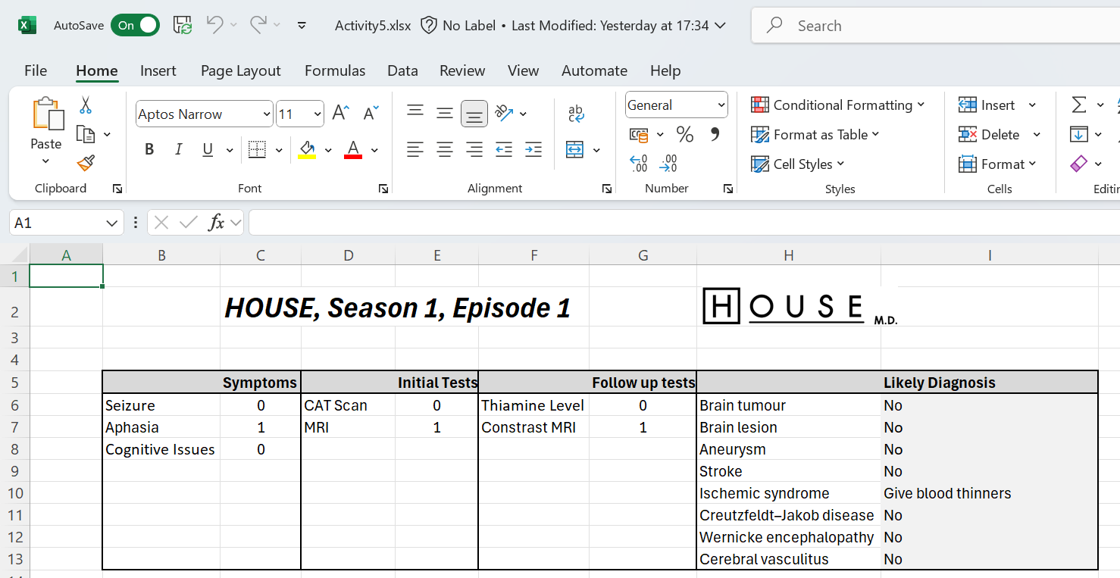
Do a screengrab of that and put it in the answer template.

Submission Instructions
Please submit in the following two ways
Please e-mail me your completed solution, and with filename:
Familyname_FirstName_TU850_1_SDSaAI_Activity5.docx
e.g.
Gordon_Damian_TU850_1_SDSaAI_Activity5.docx
Also include the answer to Activity #1-4 in separate files.
e-mail to Damian.X.Gordon@TUDublin.ie with subject heading as follows:
[DT850/1] SDSaAI Activity #1-5

Please submit into Brightspace in:
- Assessment
  - Assignments
    - Activity #5

For the email, please include the following message:
Damian,

I am a student in your Sustainable DS & AI (CMPU1040) class in the BSc in DS & AI (DT850/1).

Please find attached Activity #1-5.

Regards,
Your Name
Student Number.
DT580, BSc in DS & AI

