Some Suggestions when dealing with St. John of God’s clients
- Go into this process with an open mind and you’ll love it

- People are different, so there is no one approach to deal with people, treat everyone as an individual

- Be welcoming and positive, and take the initiative to introduce yourself and start a bit of small talk, and get them involved in the design.

- Don’t overburden non-technical people with a bunch of jargon, you might know what “transaction”, “compile” or “client-server” means, but the rest of the world might not

- Be consistent in your use to terminology, if you are talking about your phone and sometimes you call it “phone”, and others the “screen”, the “display”, it gets a bit confusing, keep it consistent.

- Some clients might prefer images to words, so make sure you bring a pen and paper to draw things

- Read a little bit about accessibility

- When you are explaining things, give a few examples

- Some clients are very agreeable, they will say “yes” to anything, so make sure they understand what you are saying; speak slowly, repeat what you have said in a few different ways, and don’t move on until you are happy they understand

- Ask them which applications they are already familiar with, and consider making your system match what they know already, even if you think there is a better way to do things, present them with both options (i.e. the “better way” and the way that is similar to what they already do).

- Guide them in the design process, don’t just ask them to design something, give them some options, and suggestions, use post-in notes to help
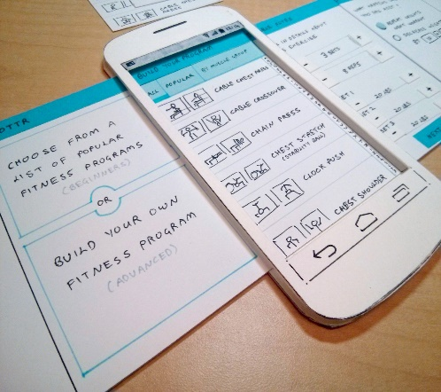 | 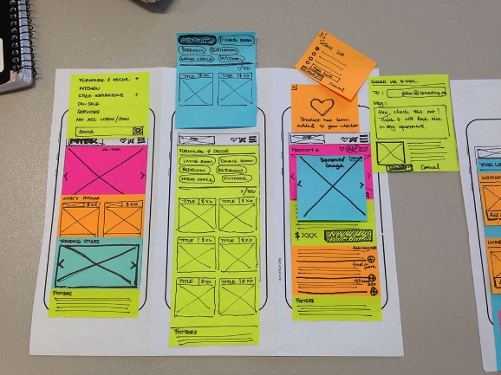

- When creating prototypes you can create them with a pen and paper or with software (Photoshop, Google pencil, etc.), different people may prefer different looks

- When displaying digital prototypes you can print them out, display them on a laptop, display them on a phone, or display them on a projector, be flexible in your approach

- Make it clear to the clients that your prototypes are conversation-starters, to encourage a creative process of co-designing your system, don’t allow them to simply agree with everything you are suggesting

- Remember:

